**Format of a Recursive Function**

* A Recursive function performs a task in part by calling itself to perform the subtasks. At some point, the function encounters a subtask that it can perform without calling itself. This case where the function does not recur , is called the base case and the function which calls itself to perform a subtask, is referred to as the recursive case.

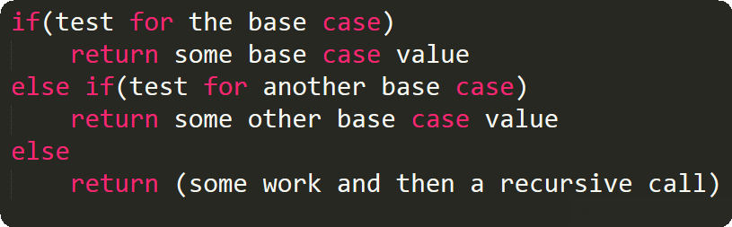

* For Example:

